27 June 2022

Dear [Insert Name],

This letter is a formal notice that we, the Oelwein Community School District have received notice of your unsportsmanlike and/or inappropriate behavior at an OCSD sanctioned game on [Date]. This behavior, if founded, is in direct violation of OCSD Board Policy 903.4 a copy of this policy has been attached for your review.

Due to the nature of your behavior and/or language if we witness or are notified of this unsportsmanlike inappropriate behavior again, you may be suspended or banned from future events with the Oelwein Community School District.

In the Oelwein Community Schools we hold our coaches, student athletes, and spectators to high standards. Unsportsmanlike and inappropriate behavior will not be tolerated toward each other, toward student athletes or towards our officials.

If you have questions you may follow up with the Activities Director or Superintendent.

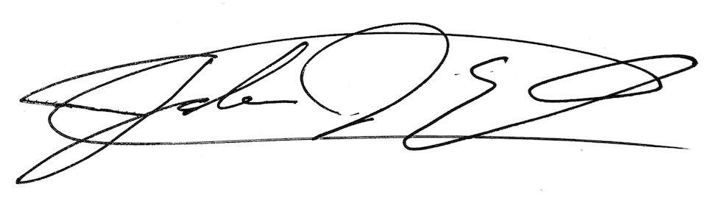
Sincerely,

Jamie Jacobs Josh Ehn
Activities Director Superintendent

